**SQL ASSIGNMENT 3**

**Submitted by:** Navyatha Godla

**Submitted on**: 10/02/2024.

**Task:** 1. Create a stored procedure to display the restaurant name, type and cuisine where the table booking is not zero.

**Code:**

create procedure usp_NonZero_Tablebooking_Jomato

as begin

Select RestaurantName, RestaurantType, CuisinesType

From Jomato as J

where J.TableBooking <> 0

end;

Exec dbo.usp_NonZero_Tablebooking_Jomato;

**Result:**

**Task:** 2. Create a transaction and update the cuisine type ‘Cafe’ to ‘Cafeteria’. Check the result and rollback it.

**Code:**

Begin transaction

update Jomato

set CuisinesType='Cafeteria' where CuisinesType='Cafe'

select RestaurantName,RestaurantType,CuisinesType from Jomato where RestaurantType='Cafe'

Rollback transaction;

**Results:**

**Task:** 3. Generate a row number column and find the top 5 areas with the highest rating of restaurants.

**Code:**

select Rank, Area, Round(Rating,2) as AreaRating

from

(select

Area, Rating,RestaurantName,

Row_number() over (order by Rating desc) as Rank

from Jomato ) as Area_Ranked

where rank <= 5;

**Result:**

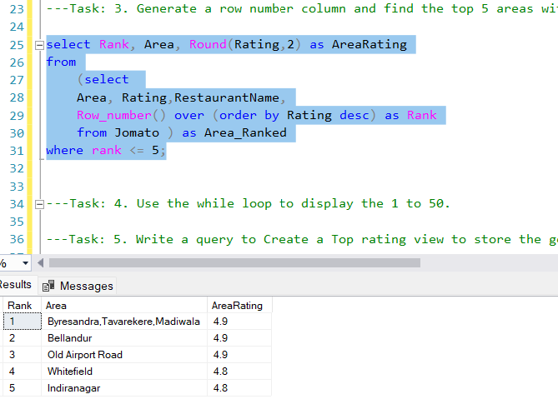

**Task:** 4. Use the while loop to display the 1 to 50.

**Code:**

declare @counter int

set @counter = 1

While @counter < 51

begin

Select * from Jomato where OrderId=@counter

set @counter = @counter + 1

end

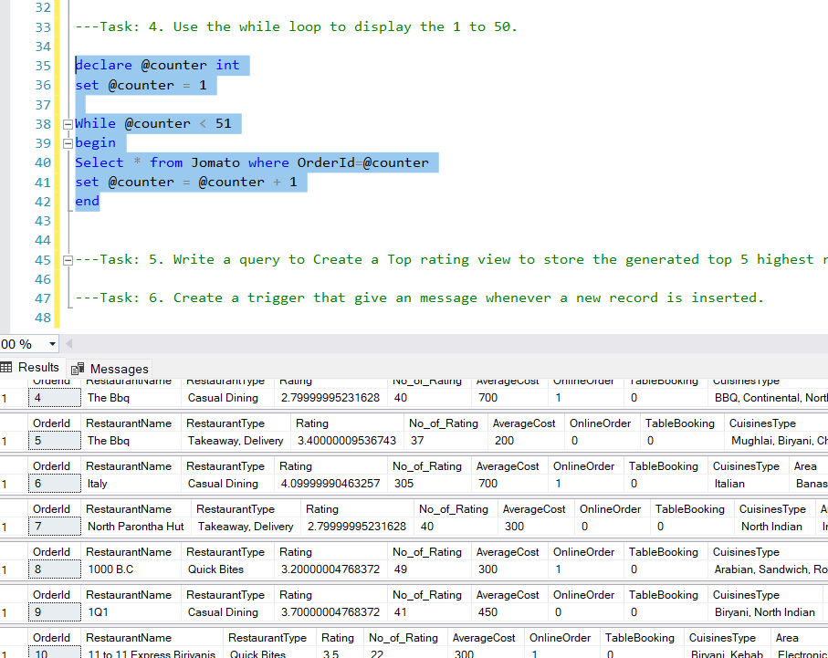**Result:**

**Task:** 5. Write a query to Create a Top rating view to store the generated top 5 highest rating of restaurants.

**Code:**

Create view vw_Top5_Jomato as

select * from

(select Row_number() over (order by Rating desc) as Rank,

RestaurantName, RestaurantType, CuisinesType,AverageCost, OnlineOrder, TableBooking, Delivery_time, Area,LocalAddress,Round(Rating,2) as Rating, No_of_Rating

from Jomato ) as Restaurant_Ranked

where rank <= 5;

select * from vw_Top5_Jomato

**Result:**

**Task:** 6. Create a trigger that give an message whenever a new record is inserted.

**Code:**

create Trigger tr_Insert_Jomato on Jomato

after insert

as begin

Select 'Order ' + cast(OrderId as varchar(20)) + ' is placed at ' + cast(getdate() as varchar(50)) from inserted

End

begin transaction

insert into Jomato values (7777,'Znew','Cafe',3.2,10,100,0,0,'Cafe','HSR','HSR',50)

Select * from Jomato order by OrderId desc

rollback

**Result:**

